Bear-Be-Gone

Automated Bear Detection and Deterrence System

University of Connecticut

School of Computing
CSE 4940, Spring 2026
5/7/2026

Nathan Auten, Jacob Bidorini, Justin Latif, Bryan Martinez

Yuan Hong – Faculty Advisor

Joint Project with ECE 2621

Background
Over the past several years, Connecticut’s black bear population has expanded further into suburban and residential regions, resulting in increased bear sightings and home entries [1,2]. Reports from CT DEEP have reflected this surge in bear-related complaints since the beginning of 2020, noting that there were more reports of bears entering homes in June of that year than all of 2019 [1].
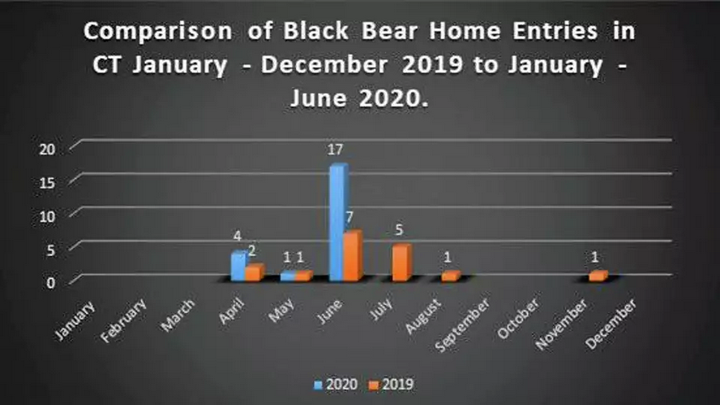
Figure 1- 2019/2020 Comparison of Black Bear Home Entries in CT [1]
In recent years, this increase in bear home entries has only continued to rise. In DEEP’s 2025 The State of The Bears report, the organization reported 67 verified home entries in 2024, alongside numerous attempted break-ins [2]. Together, these patterns indicate a sustained shift where bears are more used to human structures, now viewing them as sources of food and shelter, raising concerns for both Connecticut residents and wildlife.

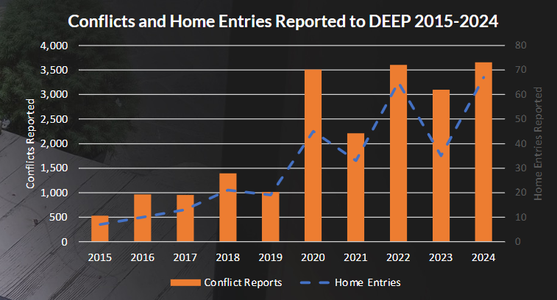
Figure 2 - CT DEEP Reported Conflicts and Home Entries, 2015 - 2024 [2]
Additionally, the personal experience of our project sponsor further highlights the real-world urgency of this problem. In 2024, Holly Beum, founder of Interface Technologies, experienced a black bear invading her property and destroying her chicken coop, resulting in damage to her property and the loss of her livestock. This tragedy shows that these events are both becoming more common and greatly impacting our community, further demonstrating the need for a deterrent strategy that is consistent, affordable, and effective to keep our homes safe.
As this was the second year of this senior design project, our goal was to improve upon the results produced by last year’s team. The previous team created a prototype that successfully detected black bears using a camera and object detection model, triggering lights and sound to deter the bear. However, their tests showed that their stimuli were not strong enough to drive bears away, and the system’s seven second reaction time was too slow for practical deployment.
This year, our team was motivated to continue solving this problem by improving the speed of the system and the strength of its deterrence. Additionally, we were faced with a new problem this year, as near the end of the fall semester, we were informed by Natural Resources & Environment professor Tracy Rittenhouse that testing our device on wild black bears would require approval from the Institutional Animal Care and Use Committee (IACUC) [3]. After submitting our project for review, we were fortunately approved by the committee and permitted to proceed with testing our project on wild black bears.
Previous Work
Last year’s team was able to develop and deploy a fully functional prototype of the deterrence system. They utilized a USB camera with a Raspberry Pi 4, which ran the computer vision model and triggered the alarm system once a bear was detected. The computer vision model used was the You Only Look Once (YOLO) version 8. The stimuli used to attempt to scare the bear away consisted of a speaker that outputs random noises at a volume of approximately 90 decibels, which is around the same volume as a chainsaw. The other deterrent was a light that would strobe to attempt to disorient the bear.
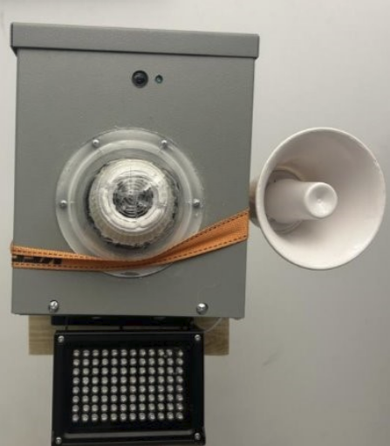
Figure 3 - Finalized device from previous years group
In live tests, the team managed to lure a bear using food as bait. When the bear attempted to eat the food, the system was able to trigger, but the bear remained focused on the food and was not deterred by the sounds and light.
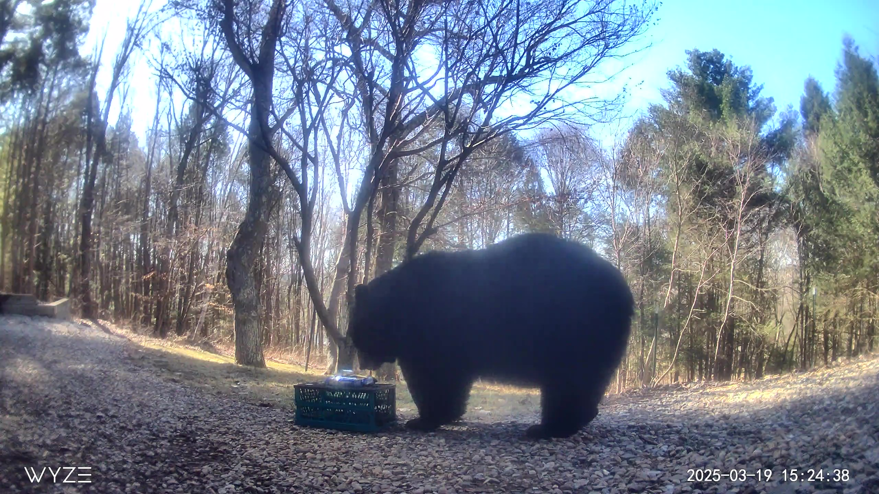
Figure 4 - Bear lured in by Oreos
The team also created a frontend website that would be able to give the customer information about their device as well as edit some settings about the device, such as what it will be actively trying to detect and what will trigger the alarms.
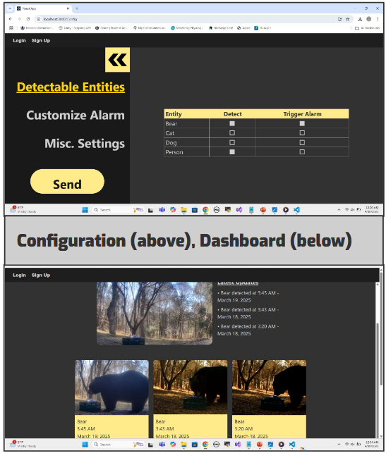
Figure 5 - Frontend from previous year
The user would also be able to see a log of events captured by the Pi, giving them an idea of how often the device is triggering and an image to go along with it, through which they could verify that there was a bear at the time of detection to confirm it was not a false trigger.
Device Specifications
This year, we have upgraded multiple components of the device. The Raspberry Pi 4 was traded out for a Raspberry Pi 5, which provided us with a CPU improvement. We also got a model with 2 GB of RAM, giving us double the amount of memory in comparison to last year's project. Alongside this greater computing power, we upgraded the Pi to the YOLO version 11 computer vision model. For the alarm parts, we went with an airhorn capable of 150 decibels, a significant increase over last year, as well as a light capable of outputting 12,000 lumens.
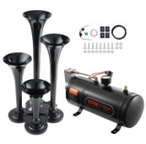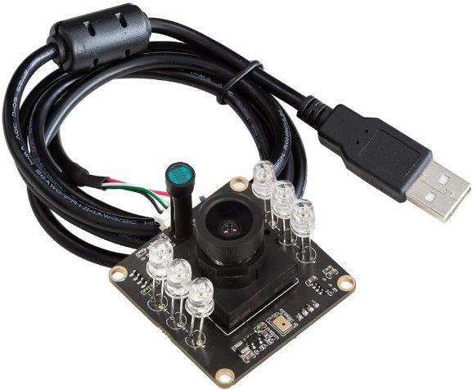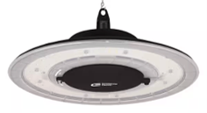
Figure 6 - IO devices used in the system

Frontend
The development of the frontend interface focused on providing homeowners with a user-friendly and responsive way to interact with the deterrence system. Rather than continuing with the previous year’s complex, multi-page security and account system with several redundant files, which was found to be unnecessarily complicated for a local dashboard overview of the Pi that already works by itself, the interface was rebuilt from the ground up using a simple modern development stack. This involved using Vite for project scaffolding and React with TypeScript to ensure a lightweight and easy to use environment. The resulting dashboard is divided into three primary functional areas: Telemetry and Controls, Latest Threat Captured, and the Event Log.
The Telemetry and Controls section provides real-time telemetry from the Raspberry Pi, including CPU temperature, memory usage, and system uptime, alongside manual overrides for the compressed air horn and LED lights if we wanted to trigger the hardware ourselves. The Latest Threat Captured section displays the most recent image captured by the camera during a detection event, accompanied by a confidence score. Finally, the Event Log maintains a chronological record of all system activities and detections, ensuring the user has a clear history of interactions. It can even be used to view past detections in case one is missed.
To facilitate real-time communication between the frontend and the backend running on the Raspberry Pi, the socket.io-client library was implemented to allow for bidirectional, low-latency updates. This ensures that when the detection model identifies a bear, the dashboard updates the live feed and event log almost instantaneously without requiring a manual refresh. During the testing phase, a significant hurdle was identified regarding the display of the live feed where browsers would often cache the detection image, leading to old visuals even after a new event occurred. To resolve this, a cache-busting logic was implemented using unique timestamps appended to the image URL, forcing the browser to fetch the most recent file from the server every time the WebSocket signaled a new detection.
While initial development was performed in a macOS virtual environment without any involvement from the Raspberry Pi 5, after extensive testing we confirmed it did work if all three elements, the frontend, the backend, and the image capturing YOLO file, were ran on a single device. Therefore, the next step was connecting the frontend to the Pi while it was running to confirm it worked when the image capturing code and the full stack still worked while on separate devices. Using Tailscale to connect to each other over a network on the UConn internet, further testing confirmed that the frontend was fully functional while the Pi used its hardware to run the camera and detect bears.
Backend
The backend was built on an asynchronous architecture that was designed to decouple the full stack solution from the detection model running on the Raspberry Pi. The system consists of two components, one script running on the Raspberry Pi dedicated to running our YOLO model, and a second script running a centralized Flask webserver that manages incoming data from the Pi, remote commands, and system telemetry data.
The script is dedicated to running our YOLO model on the Pi servers as an intelligent sensor for the system. Its main responsibility is to execute our computer vision pipeline while also managing our physical deterrent hardware. As efficiency was one of our main goals in improving the previous team’s work, the system uses a two-stage detection process. First, a lightweight motion detection system identifies movement using OpenCV. Only when motion is detected does the script execute the YOLOv11 model for object classification. Implementing a two-stage detection process ensures that the YOLOv11 model only runs when movement is confirmed, significantly reducing idle CPU usage and thermal stresses on the Raspberry Pi 5. Alongside this feature, we ensured that the detection loop would never be stalled by network latency whenever the Pi would try to upload detection images or reporting telemetry data, thus network related tasks were offloaded to background threads to prevent the detection and deterrence loops from being stalled. Lastly, whenever a bear was detected by our YOLOv11 model, physical interactions with the deterrents like the lights and airhorns were managed via a GPIOTrigger class. This provided a unified interface to turn on, off, or pulse the airhorns or strobe lights.
The Flask webserver acted as the communication hub to allow for real-time updates between the Raspberry Pi and user dashboard. The server utilizes Flask-SocketIO to create persistent bidirectional WebSockets. By leveraging this new feature, the backend can perform push-based data relay, transmitting detection data and images to the frontend instantly from the moment that the webserver receives a payload from the Raspberry Pi. This eliminates the need for inefficient user polling that was implemented in last year’s backend design, where the frontend would poll every second for new information. Alongside the usage of WebSockets, an important feature implemented was to allow users to manually override the automatic deterrents. To allow the frontend to send a signal all the way to the Pi, we employed a downstream data path using the SSE (Server-Sent Events) protocol. The server hosts a dedicated endpoint that yields queued commands as a continuous stream. On the Raspberry Pi, a ManualCommandListener class maintains a persistent outbound connection to the webserver. Using a push model for commands, it allows the Pi to receive manual horn or light triggers quickly from the dashboard. We made the decision to use SSE over Websockets, as only a unidirectional push model was required for the downstream command path. This made SSE the viable approach, as they reduce protocol overhead and simplify the persistent connection necessary for the Pi to listen for any manual triggers requested by the user.
Lastly, to ensure that our system is reliable, we incorporated a monitoring pipeline to allow for the users to see the Pi’s metrics on the dashboard. By using the psutil library, the Raspberry Pi periodically captures telemetry data like CPU usage, core temperatures, and memory usage. This data is then sent through a POST request to the webserver’s telemetry endpoint at a default interval of 30 seconds. The server then broadcasts a telemetry_update event to the user's dashboard, where the user can then see live telemetry updates.
In order to manage various configurations related to our backend, such as detection sensitivity or various URLs pointing to different endpoints in our webserver, we created a central config.json file. A centralized config file allows for rapid tuning of parameters that directly impact the performance of our model, such as sensitivity, deterrent durations, and specific animal targets without requiring code modifications.
Model Improvements
One of our largest areas of focus for this project was the optimization of our detection model, with it being the most intensive part of our code and a major limitation of last year's project. Our first step was to research other models used in similar projects and compare them to the YOLO model used by the previous team. This research showed us that most other models either required multiple iterations, large amounts of computation to produce accurate results or were far more complex to implement than YOLO [4,5,6]. This ultimately led us to select YOLO for our model family, as it showed strong detection performance relative to its high speed and efficiency, making it the best choice to run reliably on our device.
After determining the YOLO family of models as the best choice for our project, we then moved to benchmark a variety of models in the line to compare their performance directly on the Pi. There are currently 12 iterations of the YOLO detection model, each coming in a variety of different sizes, with required computation and model accuracy increasing with the model size [7]. After testing and comparing the performance of different model weights on the Pi, we found that the lighter nano (n) and small (s) versions were most practical to run on our device, as the larger models, while accurate, had too much delay or were too intensive in their detections to be used on our device.
After settling on these model sizes, we then developed benchmarks to compare the performance of the most recent YOLO releases, gathering telemetry data and accuracy metrics to create an objective comparison. This was achieved by running detection on 50 bear images and 50 dog images for each of the models while recording relevant telemetry data. The results of these tests showed that the small models were ~3% more accurate in their detections than their respective nano variants, but had a noticeably larger latency and resource usage due to their heavier computation, leading us to select the nano models for our application, as speed was a key factor for our device’s function. Specifically, the YOLO11n model showed the best performance out of all tested nano models, providing the highest accuracy with the lowest latency and memory usage.
After deciding to use YOLO11n for detection, we then tested and compared a variety of optimization techniques to further improve the model’s performance on the Pi. After researching various methods that would be best suited to this situation, we decided to focus on frame skipping, conversion to the NCNN model format, motion detection, and resolution downscaling to optimize our model [8,9,10]. These methods all aim to lower CPU and memory usage on the Pi while retaining as much accuracy and detection speed as possible. To test these optimization methods, additional benchmarks were created to read real-time telemetry data and measure each optimization’s effects on model efficiency compared to the base model.
To test the impact of frame skipping on the model’s performance, we created a live test that took a stream of frames from a connected camera as the model input, skipping a set of frames between each detection to save resources. This method proved effective, as skipping 10 frames between each run of the model lowered the average CPU usage from 70% to 40%. While lowering the frequency of the model could be a problem in some cases, it is well suited to detecting bears as they are a large and relatively slow subject. While improvements were modest, we were satisfied with the performance provided by this technique and planned to implement it in our final version.
To test the NCNN model format, we utilized the model conversion tool built into the ultralytics Python library to convert the original model from its native Pytorch format to NCNN, then ran a benchmark comparing the performance of both formats on the Pi. We were particularly interested in this optimization as it is specifically designed to provide large performance improvements on ARM processors like on the Pi, enabling the model to utilize efficiency techniques exclusive to the CPU architecture. The results of our benchmark showed massive improvements to the performance of the model on our device, with a 400% increase in inferences per second and a 78% decrease in detection latency. Overall, this optimization proved to be an essential improvement to the performance on the Pi and was a major factor in the overall efficiency of our finished device’s performance.
For motion detection, we again implemented a live video feed similar to the frame skipping benchmark, aiming to reduce computation by only running the model when motion, such as a moving bear, was detected. Our implementation checks for motion by first converting the current and previous frames to grayscale and calculating the absolute difference of the frames to highlight moving objects. A Gaussian blur is then applied to the result to reduce noise, followed by thresholding to create an array of 1s and 0s based on the result, where pixels in motion have a value of 1. The sum of the pixels is then compared to a minimum change value, triggering inference if the number of moving pixels exceeds it [11]. During testing, this strategy proved to be extremely effective, allowing the CPU to sit at near 0% usage while nothing was in frame of the camera, freeing computation to make idle processes easier to run while still providing quick detection when a subject enters the frame.
The last optimization we tested was resolution downscaling, which increases model efficiency by lowering the scale of frames sent to the model, reducing the number of pixels for the model to process in each inference [12]. Our benchmark for this method utilized the image-based strategy of the baseline YOLO and NCNN benchmarks, allowing for consistent and repeatable testing of how image resolution effects model performance. Our results from this test showed an increase in inferences per second and a decrease in memory usage and latency as the image resolution decreased, becoming more efficient the lower the resolution became. One limitation of this strategy that this test revealed was that when the resolution is set too low, in our case 320x320, the detection accuracy started to decline as the model did not have enough information to perform accurate detections. Overall, these results clearly depicted resolution downscaling as another impactful optimization for our final implementation, providing a boost to efficiency with little to no accuracy reduction as long as the resolution was not set too low.
Once we were satisfied with the results of our testing, we then moved to layer these optimization strategies to create the most efficient model for our task while remaining as accurate as possible. First, we converted the model to the NCNN format with a configured inference resolution of 480x480 as a recompiled version of the YOLO11n model, as the format requires any changes to resolution be specified during the conversion of the model rather than at runtime. Once this optimized file was created and verified, we then tested it with both frame skipping and motion detection in the same detection loop. While this seemed to be a good strategy in theory, our testing showed that the combination of these techniques resulted in inconsistent triggering of the model, as model inference triggered by motion detection would frequently be blocked on frames on frames that were already set to be skipped, requiring both conditions to line up perfectly for inference to occur. After reviewing this issue, we decided to remove frame skipping from our final implementation, as the inconsistencies it introduced were not worth the 30% computation savings, especially when compared to the more impactful savings motion detection provided while the device was idle. As a result, the final implementation of our model consists of the YOLO11n model converted to NCNN, preset to process images at 480x480 while being triggered by our motion detection logic, striking the right balance between efficiency and accuracy. Overall, we found the optimizations made on our model to be a major improvement over last year’s implementation, as there is no longer any delay between detecting a bear and triggering deterrents, with computation also being greatly reduced when there is nothing to detect.

Field Testing & Results
With approval from the UConn’s Institutional Animal Care and Use Committee (IACUC), we were able to set up a live field test in our sponsors backyard. The device was placed near the chicken coop that was previously destroyed by a bear, aimed towards two towels that had been saturated with a bear attractant spray.
Two external game cameras, provided by Dr. Rittenhouse of the Department of Natural Resources and the Environment, were also placed to capture further pictures and videos of a bear’s interaction with the device. Our sponsor also allowed us access to a Wyze camera that would give us a live feed and notification if a bear was detected. Within 3 days of the device being deployed, a bear was attracted to the towels and subsequently deterred from the test site upon activation of the device. While no further bears appeared during the testing period, this was able to prove that our device, unlike last year’s, had sufficient stimuli to deter a bear.
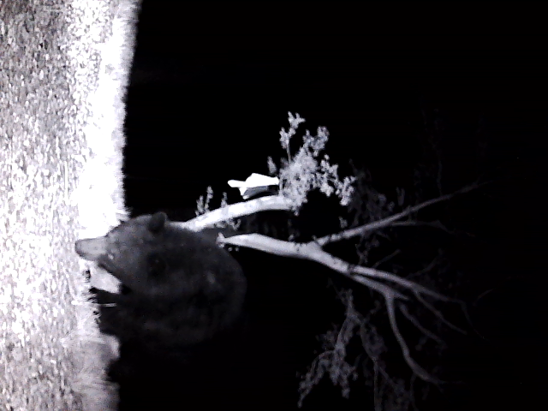
Figure 7 – Bear image captured by the device

Conclusion
Paired with NCNN compiled YOLOv11n model, motion detection, and resolution downscaling, the device was able to run at much higher efficiency, with the device idling around ~0% CPU usage when no motion is detected. Alongside the streamlined frontend, there is now an effective end-to-end pipeline of detection, deterrence, and ability for the user to see the logs of events and monitor the health of the device.

Works Cited
[1] CT Post. “DEEP: More Bears Entering CT Homes.”
https://www.ctpost.com/local/article/DEEP-More-bears-entering-CT-homes-gravely-15407487.php
[2] Connecticut Department of Energy & Environmental Protection. 2025: The State of the Bears Report.
https://portal.ct.gov/-/media/deep/wildlife/pdf_files/2025-the-state-of-the-bears.pdf
[3] NIH Office of Laboratory Animal Welfare. “Institutional Animal Care and Use Committee (IACUC) Guidance.”
https://olaw.nih.gov/resources/tutorial/iacuc.htm.
[4] Roboflow. “Best Object Detection Models.”
https://blog.roboflow.com/best-object-detection-models/.
[5] DigitalOcean. “Guide to the Best Object Detection Models.”
https://www.digitalocean.com/community/tutorials/best-object-detection-models-guide.
[6] HiTech BPO. “Top Object Detection Models: A Visual Processing Review.”
https://www.hitechbpo.com/blog/top-object-detection-models.php.
[7] Ultralytics. “YOLO Model Documentation.”
https://docs.ultralytics.com/models/
[8] Ultralytics Blog. “What is Model Optimization? A Quick Guide.”
https://www.ultralytics.com/blog/what-is-model-optimization-a-quick-guide.
[9] Medium – Academy Team. “Model Optimization Techniques for YOLO Models.”
https://medium.com/academy-team/model-optimization-techniques-for-yolo-models-f440afa93adb.
[10] Ymer Digital. Object Detection Performance Analysis.
https://ymerdigital.com/uploads/YMER230539.pdf.
[11] LearnOpenCV. “Moving Object Detection with OpenCV.”
https://learnopencv.com/moving-object-detection-with-opencv/.
[12] Ultralytics Documentation. “YOLO Data Augmentation – Translation.”
https://docs.ultralytics.com/guides/yolo-data-augmentation/#translation-translate.

